FT8Flow v1.61.5
Complete How-To Manual
Operator guide to the FT8Flow changes and additions derived from WSJT-X
Independent derivative maintained by W7PP
Edition: October 2026
This manual documents FT8Flow-specific behavior and changed features. For standard WSJT-X operation that FT8Flow does not change, continue to use the official WSJT-X documentation.
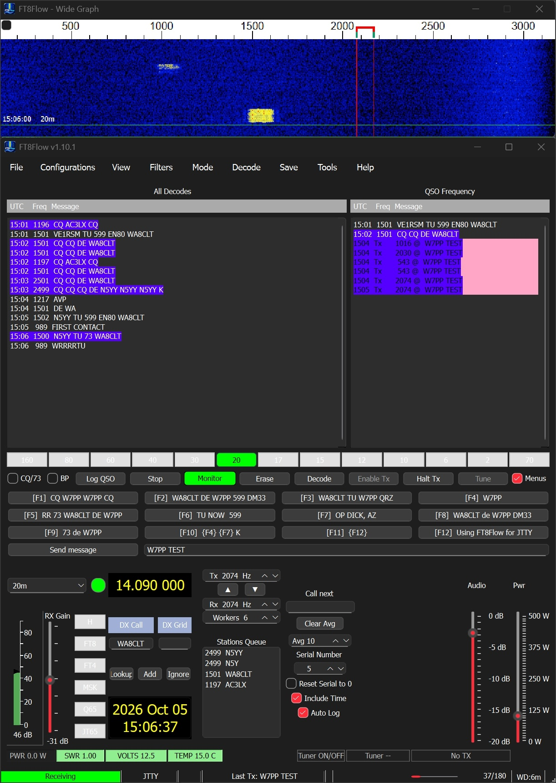
Current approved FT8Flow v1.61.5 main window and Wide Graph screenshot used for this manual.
Important note
Because the available additional screenshots were not current, this manual uses the current October 5 main-window screenshot and enlarged crops of that screenshot. Configuration dialogs and other windows that are not shown in the current screenshot are documented accurately in text.

Contents
- 1. Scope and how to use this manual
- 2. Installation and first launch
- 3. Main window overview
- 4. JTTY operating area
- 5. Core FT8Flow operating features
- 6. Native FLEX / VITA-49 functions
- 7. Logging, contest tools, and external integration
- 8. Kiwi Remote bridge
- 9. Identity, compatibility, and support files
- 10. Troubleshooting
- 11. Quick reference

1. Scope and how to use this manual
FT8Flow is an independent derivative of WSJT-X. This manual explains the FT8Flow changes and added operator-facing features only. It is intentionally not a replacement for the standard WSJT-X user guide.
Use this manual for features that are different in FT8Flow, including the Native FLEX/VITA-49 functions, compact layout and added operating controls, contest and logging additions, Kiwi Remote support, and the current JTTY operating interface.
Use the upstream WSJT-X guide for ordinary settings, standard FT8/FT4 procedure, waterfall basics, and other stock functions that FT8Flow does not change.
- This edition is based on the accepted FT8Flow v1.61.5 identity and the current approved main-screen capture.
- The executable filename may still remain wsjtx.exe for compatibility even though the operator-facing product identity is FT8Flow.
- Local settings and some support files remain in the normal WSJT-X data locations for compatibility.

2. Installation and first launch
Extract the complete FT8Flow release ZIP into its own folder. Keep the program, helper executables, libraries, plugins, and support files together. Do not run FT8Flow from inside the ZIP file.
- Create a dedicated FT8Flow folder on the target PC.
- Extract the full release package into that folder.
- Start the program from the extracted runtime folder.
- Confirm the title bar identifies FT8Flow v1.61.5.
- Open Help / About FT8Flow and confirm the product identity and derivative notice.
- Before transmitting, verify callsign, grid, correct time, radio path, RX path, TX path, and logging destinations.
Compatibility note: FT8Flow intentionally retains the WSJT-X-compatible local configuration/data location. This is why FT8Flow-related files may still appear under %LocalAppData%\WSJT-X.
What stays the same as WSJT-X: If a control or procedure is not described as changed in this manual, use the normal WSJT-X documentation and workflow.

3. Main window overview
The current FT8Flow main screen combines the standard WSJT-X decode-and-operate idea with a denser compact layout and several added controls. The figure below is the primary current-screen reference for this manual.
Figure 1 - FT8Flow v1.61.5 main window and Wide Graph.

3.1 Wide Graph
The Wide Graph remains the main visual tuning display. In the current screen it appears as a separate top window. It provides the band activity picture, passband view, and the normal receive/transmit frequency markers.
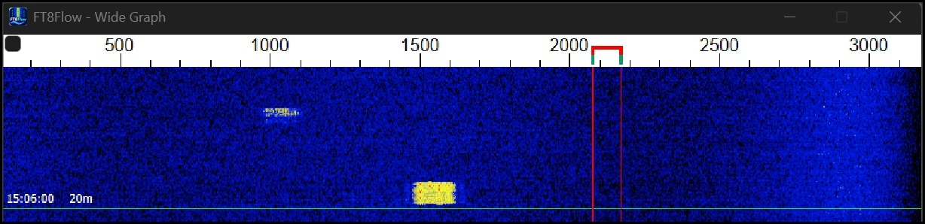
Figure 2 - Wide Graph crop.
- Use it to see activity across the passband and to place or confirm operating frequency.
- The green and red marker regions show the working frequency area.
- Wide Graph placement is remembered when the program is closed normally.
- FT8Flow includes display-size and resizing improvements so the main window and Wide Graph can be positioned more flexibly.

3.2 Decode panes
The center of the main window contains the All Decodes pane and the QSO Frequency pane. These keep the familiar WSJT-X operating model while fitting the compact FT8Flow layout.
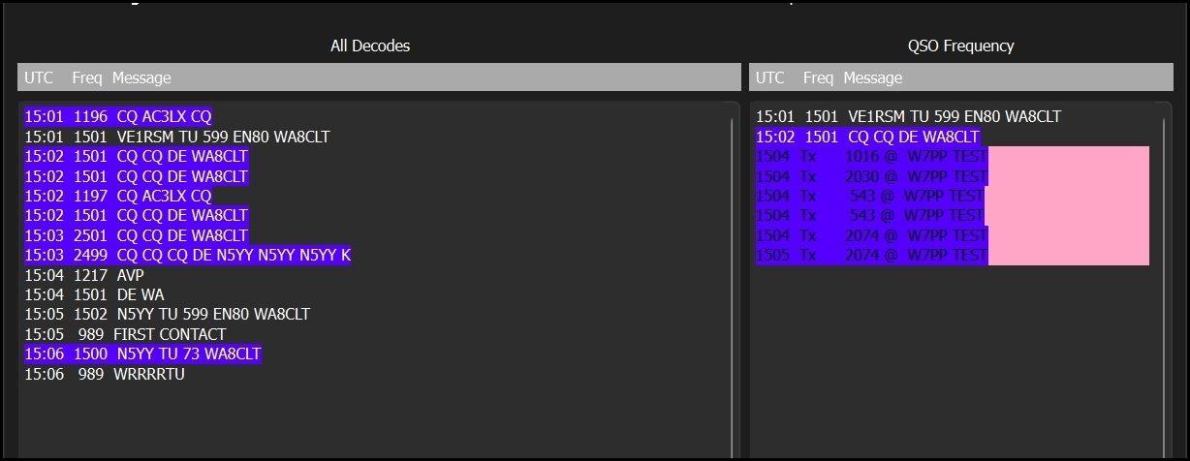
Figure 3 - All Decodes and QSO Frequency panes.
- All Decodes shows general received traffic.
- QSO Frequency focuses on messages at the active working frequency.
- In current JTTY operation, transmitted entries are also visible in the QSO Frequency area.
- Double-click and frequency behavior may depend on operating mode and current feature state; for unchanged behavior use the normal WSJT-X approach.

3.3 Main control strip
Below the decode panes is the compact operating strip. It keeps key actions close together so the operator can monitor, decode, log, and sequence messages quickly.
- CQ/73 and BP are operating-option checkboxes used by the current mode/workflow.
- Log QSO writes the contact using the current logging path.
- Stop stops the current activity.
- Monitor turns reception/monitoring on or off.
- Erase clears the displayed decode text areas.
- Decode forces a decode pass.
- Enable Tx arms the station for transmission; Halt Tx stops current transmission activity.
- Tune keys a tuning carrier/drive path when appropriate for station setup and mode.

3.4 Function-key message rows and free-text message area
The current JTTY screen uses two rows of programmable function-key messages plus a free-text send-message entry line. This provides a contest-style operating workflow from the main window.
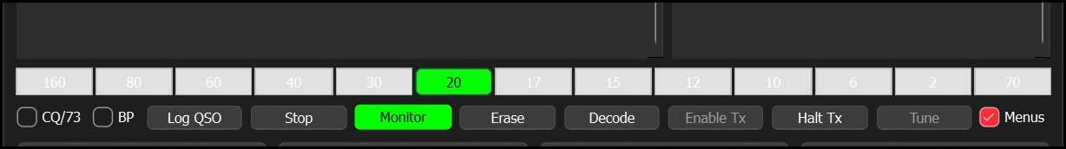
Figure 5 - JTTY function-key message rows and free-text field.
- F1 through F12 hold operator messages/macros.
- The free-text line lets you type or edit a message directly.
- This area is intended for rapid manual operating and contest-style exchanges.
- When editing or creating macros, keep your callsign, exchange, and operating style consistent with the current contest or normal operating use.

3.5 Left-side operating controls
The lower-left control group combines band selection, main frequency display, RX Gain, DX call/grid fields, lookup/add/ignore actions, and the date/time display.
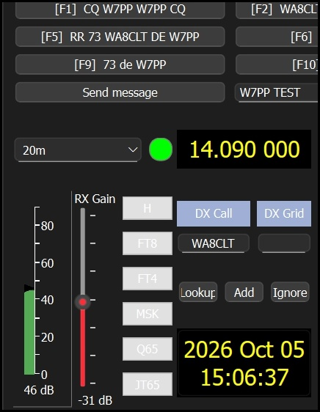
- Band and the large frequency display remain the primary operating-frequency controls.
- RX Gain is the FT8Flow Native FLEX receive-attenuation control when Native FLEX RX is active.
- The DX Call and DX Grid fields track the current target station information.
- Lookup, Add, and Ignore provide quick call-handling utilities.
- The date/time display gives a large at-a-glance UTC/local operating reference depending on your current configuration.

3.6 Center operating controls
The center-lower group contains the current transmit and receive audio frequencies, the Workers display, Call next, the Stations Queue, averaging, and the contest serial / Auto Log controls.
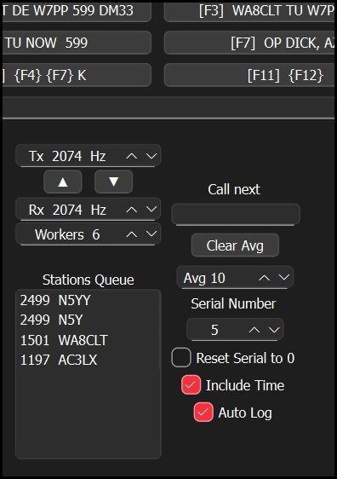
Figure 7 - Center controls: Tx/Rx frequency, Workers, queue, averaging, serial number, Include Time, and Auto Log.
- Tx and Rx frequencies show the current operating tones/frequencies.
- Workers displays the current decoder-worker count chosen by FT8Flow.
- Stations Queue shows the active waiting list used by the Multi-Answer single-stream workflow.
- Call next advances to the next queued station when appropriate for the operating sequence.
- Avg controls display/averaging behavior for the current mode.
- Serial Number holds the current contest serial value.
- Reset Serial to 0 is a guarded manual reset option intended for the start of a new contest or a deliberate reset.
- Include Time adds time information to the current logging/reporting workflow when selected.
- Auto Log automatically logs completed contacts according to the current workflow.

3.7 Right-side power controls
The lower-right group contains separate Audio and Pwr sliders in the current Native FLEX layout.
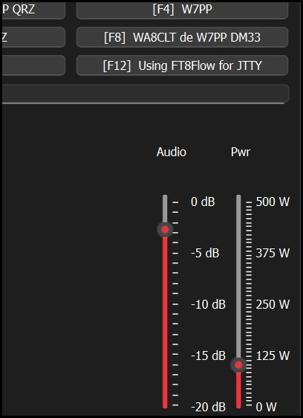
Figure 8 - Audio and Pwr controls.
- Audio is the Native FLEX TX-audio attenuation slider and runs from 0 dB toward -20 dB.
- Pwr becomes requested RF power in watts when Native FLEX is selected.
- For non-FLEX operation, Pwr continues to act as the FT8Flow/WSJT-style transmit-audio attenuation control rather than watts.

3.8 Bottom status and FLEX telemetry row
At the bottom, FT8Flow provides the main receive/TX state line, current mode indication, last transmitted message, tuner controls, TX-level area, progress information, and the FLEX telemetry row.
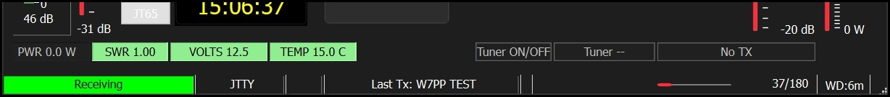
Figure 9 - Bottom status and FLEX telemetry row.
- The green Receiving area shows receive state.
- The current operating mode is shown near the bottom center (JTTY in the current screenshot).
- Last Tx reports the most recent transmitted message or macro.
- The FLEX telemetry row provides PWR, SWR, VOLTS, and TEMP when Native FLEX is active.
- Tuner ON/OFF and the tuner status/ByPass area control and report tuner state.
- The No TX / LEVEL area reports TX level telemetry when transmitting and no-TX state while receiving.

4. JTTY operating area
The current approved screenshot shows FT8Flow operating in JTTY. JTTY uses the compact main-window arrangement shown above and is intended to let the operator work directly from the main window with message buttons, queue management, and contest-oriented controls.
Because current screenshots for secondary windows were not available, this section focuses on the visible JTTY controls shown in the approved screen.
- Use the function-key rows for standard JTTY messages and exchanges.
- Use the free-text field when you need to send a custom message.
- Use Monitor to start or stop receiving/monitoring.
- Use Decode when you want to force a decode pass.
- Use Log QSO to log the current contact using the active logging workflow.
- Use the Stations Queue, Call next, and serial controls when working contest-style sequences.
- Auto Log lets FT8Flow log completed contacts automatically when the workflow supports it.
Message and macro management: Keep macro text aligned with your current operating style. If you have imported or created contest-specific macros, verify the function-key text before operating on the air.
Serial control use: The Serial Number field is for current contest serial operation. Reset Serial to 0 should be used carefully because it affects future serial numbering. A guarded confirmation workflow is intended for this action.

5. Core FT8Flow operating features

5.1 Auto CQ
Auto CQ returns FT8Flow to calling CQ automatically after a completed QSO or after an unanswered caller reaches the retry limit. Turn it on when you want the station to continue calling automatically. Turn it off when you want FT8Flow to stop transmitting after a failed attempt or completed contact.

5.2 Retry Limit
Retry Limit is the operator-selected number of report-message attempts. In the accepted FT8Flow behavior, this is a fixed operator choice rather than a signal-strength-derived value. A typical operating value is 3 attempts.
- Use a smaller value when you want faster turnover.
- Use a larger value when you want to be more persistent with weak or intermittent callers.
- When the retry limit is exhausted, Auto CQ determines whether FT8Flow resumes calling CQ or stops.

5.3 Multi-Answer Single Stream
FT8Flow includes a single-stream Multi-Answer/queue-assist workflow. This means one station remains the active QSO while one additional suitable caller may wait in the queue. It is not a two-signal simultaneous transmission system.
- One caller is active at a time.
- One additional suitable caller may wait in the queue.
- After the active QSO completes, the queued caller is promoted next.
- The Stations Queue and Call next area on the main screen support this workflow.
- Ignored calls are not eligible for automatic selection or queueing.

5.4 Ignore Calls
FT8Flow includes an Ignore Calls list so selected callsigns are not automatically chosen or added to the queue. Ignored stations still appear in decodes; they are simply excluded from automatic selection behavior. Menu path: Tools > W7PP Ignore Calls (or the FT8Flow equivalent label in your current build). Use Add, Remove, Clear, and Save to manage the list.

5.5 Decoder Workers
FT8Flow uses its own decoder-worker policy and shows the current worker count on the main window. The display is mainly status information for the operator. FT8Flow chooses the worker count automatically and may adjust it after startup.

5.6 Display size and compact layout
FT8Flow includes saved display-size options and compact layout improvements. These changes help keep the interface usable on a range of screen sizes while preserving the main operating controls on one screen.
- Use the FT8Flow/W7PP display-size command from the Tools menu.
- Select the desired percentage and restart the application normally.
- Wide Graph placement is remembered after a normal close.

5.7 Distance, bearing, and B4 appendage
FT8Flow also includes compact display handling for distance, bearing, and B4 information in decode presentation. These are operator-assistance additions and do not change the standard WSJT-X exchange protocol.

6. Native FLEX / VITA-49 functions
Native FLEX support is one of the largest FT8Flow additions. These functions apply when the FLEX Native VITA-49 radio backend and/or Native FLEX RX are selected. When another radio backend is selected, the FLEX-specific controls collapse or are hidden and ordinary WSJT-X-style radio/audio paths remain available.

6.1 FLEX discovery and radio selection
Opening the Radio settings page triggers FLEX discovery. FT8Flow does not keep a continuous discovery listener running in the background. Select Flex Native VITA-49 in Settings > Radio, allow discovery to complete, then select the intended radio and apply the settings.

6.2 Native VITA-49 receive and DAX channel
In Settings > Audio, select Native Flex VITA-49 RX when you want direct network receive audio. Then choose the correct FLEX DAX channel for the intended slice. In this mode, a normal Windows DAX input device is not the receive source.

6.3 RX Gain
Native FLEX RX adds its own RX Gain attenuation control from -60 through 0 dB. Use 0 dB when no attenuation is needed. Increase attenuation only when the direct VITA receive level is too high.
Setting | Meaning
0 dB | No FT8Flow attenuation
-10 dB | 10 dB attenuation
-30 dB | 30 dB attenuation
-60 dB | Maximum FT8Flow attenuation

6.4 Separate Audio and Pwr controls
With Native FLEX selected, FT8Flow separates RF power from TX-audio attenuation. Audio controls digital TX drive/attenuation. Pwr controls requested RF power in watts. LEVEL is telemetry only; it reports what the radio is doing and is not the same thing as Audio or Pwr.

6.5 Direct TX/PTT and SmartSDR coexistence
FT8Flow uses a direct FLEX backend that creates and controls its own operating slice, transmits audio over the network path, and keys/unkeys the radio through the FLEX API. SmartSDR may remain running on the same PC. FT8Flow uses its own slice rather than taking over an existing SmartSDR slice, provided the radio has a free slice available.
- FT8Flow Native FLEX does not require SmartSDR CAT, virtual COM ports, or a Windows DAX TX audio device.
- During FT8Flow transmit, FT8Flow uses its own slice as the TX slice.
- After transmission ends, the prior SmartSDR TX-slice selection is restored.
- Close FT8Flow normally so it can clean up its own slice.

6.6 Safety gate and TX inhibit behavior
Native FLEX transmission uses an independent safety/telemetry path and a fail-closed pre-key safety gate. If FT8Flow reports a Native FLEX TX INHIBITED condition, correct the underlying radio/interlock/network condition and then deliberately re-enable transmit. FT8Flow does not silently resume transmitting after a safety trip.

6.7 FLEX meter row and tuner controls
The bottom meter row displays live radio telemetry when Native FLEX is active.
Item | Purpose | Operator meaning
PWR | Forward power telemetry | Confirms actual RF output
SWR | SWR telemetry | Watch for high SWR before extended operation
VOLTS | Supply voltage telemetry | Confirms radio supply health
TEMP | PA temperature telemetry | Watch for excessive heating
ATU / ByPass | Manual tuner control and status | Use when you want to tune or bypass intentionally
LEVEL / No TX | Transmit-level telemetry | Shows No TX in receive; live level while transmitting
High SWR does not automatically force a tune. Tuner ON/OFF requests tuning when the tuner is off or bypassed. Use ByPass only when you deliberately want the tuner bypassed.

7. Logging, contest tools, and external integration

7.1 Today's Work Log
Today's Work is a session-oriented log view for the current operating session. It is intended as a quick, convenient summary without replacing the permanent ADIF log.

7.2 Contest Setup and contest status
FT8Flow includes contest-setup additions and contest-status display on the main window. Use the contest setup window to choose the operating contest/activity and related parameters before opening the contest logger or sending contest data externally.

7.3 Universal Contest Logger
FT8Flow includes the W7PP Universal Contest Logger (earlier manuals may call it the W7PP Contest Logger or Contest Pro Contest Log). It is a contest-focused logging view and export path that complements the normal WSJT-X/FT8Flow ADIF logging.
- Use the contest logger for contest-specific recording and exports.
- Normal ADIF logging remains part of the workflow.
- The contest logger opens only when a supported contest/activity is selected.

7.4 N1MM+ contest logging
FT8Flow can feed N1MM+ according to the current contest/logging choices. Verify server/port information and contest-only routing as required by your current configuration. When testing a new system, always make a sample contact and verify it appears correctly in N1MM+ before relying on it in competition.

7.5 Logging compatibility and duplicate policy
Normal FT8Flow/WSJT-X ADIF logging remains the permanent general log path. Depending on your selected options, contest logging, Today's Work, JTAlert/DXKeeper, and N1MM+ can all receive the same operating information through their intended paths.
- General QSOs continue to go to the standard ADIF log.
- Today's Work is session oriented and is not a substitute for the permanent ADIF file.
- Contest logger records contest information and exports.
- External workflows such as JTAlert, DXKeeper, and N1MM+ remain compatible when configured correctly.

8. Kiwi Remote bridge
FT8Flow retains support for the optional W7PP Kiwi Remote bridge. The Kiwi Remote application is separate from FT8Flow and has its own operating manual. FT8Flow checks for the Remote at startup and can start a fresh check cycle from the Tools menu.
- FT8Flow never starts or stops the Kiwi Remote application by itself.
- If the Remote is absent, FT8Flow continues to operate normally.
- Remote check status is intentionally quiet during normal successful operation.

9. Identity, compatibility, and support files
FT8Flow is the operator-facing product identity. Historical W7PP-MODS labels may still exist inside source comments or internal development markers, but the product/distribution name shown to the operator is FT8Flow.
- Title bar and Help/About should identify FT8Flow v1.61.5.
- Upstream attribution and GPLv3 notices remain in force.
- The executable name or compatibility identifiers may still use WSJT-X-derived names where needed for compatibility.
- Configuration files and some support files intentionally remain in WSJT-X-compatible locations.

10. Troubleshooting
Symptom | Check
Title or About screen is wrong | You may be launching an older executable or folder. Start the intended FT8Flow v1.61.5 runtime.
No decodes appear | Verify Monitor is on, the correct RX path is selected, and the radio/audio source is active.
Native FLEX radio not found | Check network reachability, then reopen Settings > Radio and repeat discovery.
Native FLEX RX level is too high or too low | Adjust RX Gain and verify the selected DAX channel / Native RX path.
Power acts in watts instead of dB | That is expected in Native FLEX mode. In non-FLEX mode, Pwr returns to attenuation behavior.
No TX after a safety event | Correct the radio/interlock/network issue and deliberately enable TX again.
Contest logger will not open | Verify a supported contest/activity is selected first.
N1MM+ does not receive QSOs | Verify the external logging settings, server/port, and current contest-only routing.
Older screenshots do not match your current screen | This manual intentionally uses one current main screenshot and enlarged crops rather than obsolete windows.
Queue behavior seems wrong | Review Multi-Answer, Ignore Calls, Call next, and the current Stations Queue list.

11. Quick reference
Feature | Where to find it | Key point
Wide Graph | Separate top window | Main passband/activity display
All Decodes / QSO Frequency | Center of main window | Primary received-message panes
Monitor / Decode / Log QSO | Main control strip | Core operating actions
F1-F12 macro rows | Below main control strip | Rapid JTTY/operator messages
Band and large frequency display | Lower left | Main tuning / operating frequency area
RX Gain | Lower left | Native FLEX RX attenuation
Tx / Rx / Workers | Lower center | Operating frequencies and worker status
Stations Queue / Call next | Lower center | Single-stream Multi-Answer queue support
Serial Number / Include Time / Auto Log | Lower center | Contest-style operating aids
Audio / Pwr | Lower right | Native FLEX TX-audio and RF power controls
PWR / SWR / VOLTS / TEMP | Bottom row | FLEX telemetry
Tuner ON/OFF / LEVEL | Bottom row | Manual tuner and TX-level status
Ignore Calls | Tools menu | Prevents automatic selection/queueing of chosen calls
Display size | Tools menu | Saved scale/layout aid
Today's Work | Tools > Log | Current-session log summary
Contest Logger | Tools menu | Contest-focused logging and exports
Kiwi Remote check | Tools menu | Optional bridge to the separate Kiwi Remote app
End of FT8Flow v1.61.5 Complete How-To Manual. For unchanged WSJT-X behavior, use the official WSJT-X documentation together with this FT8Flow-specific manual.

